Title: Linking Output and inflation
Subject: MTP 8

1. General Labor market equilibrium  2. Write the Output-Inflation Relationship  A. Assuming only flexible firms (LR)  B. Assuming only sticky firms  C. Looking at the real market (SR)  3. Plotting AS  4. Demand Shocks  5. The Phillips Curve  What’s π^{ε}  What’s Y^{e} | Merge Demand and supply  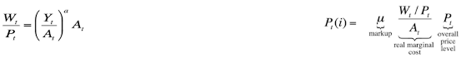  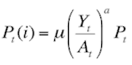  --> substitute wage from supply into demand. General Labor market equilibrium equation:  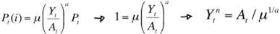  Flexible firms can adjust their prices istantly  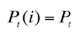  With flexible prices all firms set the same price (same MC):  This is the scenario where output is at the natural level.  Output depends on (i) Technology At (more tech more output) and (ii) monopolistic competition in good markets μ (the lower the markup the more competitive the market thus the better for output)  Filling prices with natural level of output, prices at the natural level:  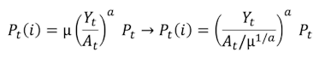  Sticky price firms can’t change P today, they can change for t+1 wrt expectations. Today P is the result of yesterday’s expectations:  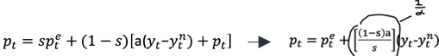  Let s = fraction of sticky price firms; and 1 - s = flexible firms:  Usually that’s the AS equation we plot --> 1/α is the slope of the AS curve (recall: output gap is in log = is the % change in output)  Interpretation:  First term: STICKY FIRMS RESPOND TO FUTURE PRICE EXPECTATIONS. We are in t, suppose firms expect high price level pte --> firms expect high nominal MC, for given real MC --> sticky price firm set high price $p_{t}^{e}(i)$ --> consequently also flexible price firms set high price p_{t}(i) NOW --> this leads to high overall price level pt  Second term: FLEXIBLE FIRMS RESPOND TO DEVIATIONS IN OUTPUT. High demand/output yt --> flexible price firms set high price p_{t}(i) --> this leads to high overall price level pt --> hence, high yt leads to high p_{t}. If we are not at natural level sticky are stuck, flexible take the sticky price in Pt and adapt following output  Rewrite:  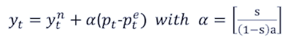  Interpretation:  Sticky-price model: deviation of yt from ytn positively associated with deviation of pt from pte. The higher the number of sticky firms the higher the effect of inflation on the output gap and, consequently the higher the reduction in unemployment. Intuitively: when Pt > Pt^{e} some firms are stuck (sticky firms) with lower prices than optimal; these firms face higher demand for their products than with flexible prices; they raise their production to meet the higher D and aggregate output rises above the natural level. Eventually, when all prices will be adjusted upwards, demand will be back to the original level. If all firms are flexible the price increase is immediately internalized, production is reduced and no gap, no employment is created, there is no excess demand. Inflation raises immediately. This would mean that monetary policy works perfectly to raise inflation without altering output.  Stickiness in practice: Consider the equation: $P_{t}- P_{t}^{e}=[ \frac{\left(1-s\right)a}{s} ](y_{t}-y_{t}^{n}$),  A. low proportion of sticky firms  If s = 0.1 $[ \frac{\left(1-s\right)a}{s} ]$ = 9a  Δp = 9a Δx: if Δx up by 1%, Δp up by 9a% --> high effect of output increase to inflation. Flexible firms will immediately adjust prices after demand shocks --> high effect of inflation in the SR  however Δx = Δp / 9a: an increase in prices will determine a weak effect on demand, being the firms flexible they will , and will immediately adjust their prices, hence avoiding any significant increase in demand  B. high proportion of sticky firms  If s = 0.9 $[ \frac{\left(1-s\right)a}{s} ]$ = 0.11a clearly previous resoning is inverted  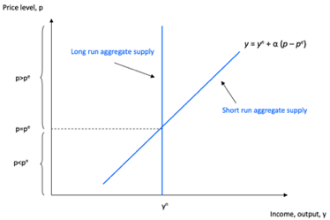  LR (no shocks)= perfectly flexible prices pt = pte --> Long-run AS vertical  SR= sticky prices --> Short-run AS upward sloping, the more stickiness the lower the slope  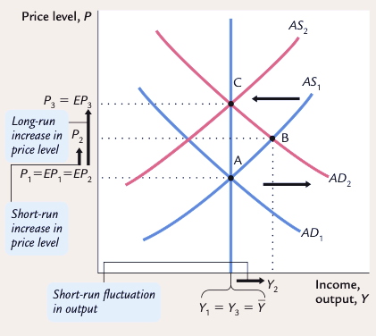  Consider an unexpected increase in AD (ex. unexpected confidence shock).  1. Sticky firms propose a price in t2 which is anchored with p₂e, so they propose p1, while flexible firms propose an higher price p2 overproduction from sticky firms, higher prices due to flexible firms.  2. Sticky firms adjust their expectations EP3 --> AS shift up equilibrium of economy moves form B to C. The actual price level rises from p2 to p3 and output falls from y2 to y3. The economy returns to the natural level of output but at a higher prices  Movement of the economy from A to B: short run monetary non neutrality  Movement of the economy from A to C: long run monetary neutrality  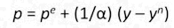  1st expression for Phillips curve  from AS (exact same formula):  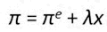  now, subtract pt-1 on both sides:  the price differences are the % change in price (Inflation):  Add supply shocks (oil), unrelated to MP (exogenous):  Note: l = 1/a, x = % difference  The Phillips curve illustrates the short run trade-off in stabilizing inflation and output/unemployment.  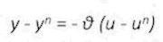  2nd expression for Phillips curve  Okun’s law (empirically observed):  --> $\frac{(y – y^{n})}{θ}$ = - (u - u^{n}), but θ = γ/λ --> λ $\frac{(y – y^{n})}{γ}$ = - (u - u^{n}) --> Since λ($y – y^{n}$) = π - π^{e} – ν --> π = π^{e} - γ(u - u^{n}) + ν  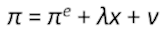  The problem is, what’s π^{ε}?  Α. Adaptive expectations Theory  Current inflation depends on past inflation. Solow: “we have inflation because we expect inflation, and we expect inflation because we’ve had it.’’ This implies inflation has inertia, it keeps going if you don’t stop it if unemployment is at NAIRU inflation keeps going at same pace without accelerating / decellertaing. In our model, inflation inertia is interpreted as persistent upward shifts in both AS and AD. The AD must also shift upward to confirm the expectations of inflation. Most often, the continued rise in AD is due to persistent growth in the money supply. If the Fed suddenly halted money growth, AD would stabilize, and the upward shift in aggregate supply would cause a recession. The high unemployment in the recession would reduce inflation and expected inflation.  From π = $π^{e}$ + λx l sacrifice ratio, the percentage of a year’s real GDP that must be forgone to reduce inflation by 1%. A typical estimate is about 5to achieve -1% inflation u need to sacrifice 5% GDP. In terms of unemployment: Okun’s law says that a change of 1% in the unemployment rate translates into a change of 2% in GDP.  Note: A rapid disinflation is sometimes called the cold-turkey, but u can also do it more gradually. Empirically: rapid disinflations usually had smaller sacrifice ratios than slower ones. That is, in contrast to what out basic PC suggests, a cold-turkey approach appears less costly. Moreover, countries with more flexible wage-setting institutions, such as shorter labor contracts, had smaller sacrifice ratios. These findings indicate that policies and institutions can affect costs of disinflation.  B. Rational expectations Theory  People make forecasts on future inflaiton based on CB/ Gov policies and care of it. It is actually the L-R Gov policy of persistently running large deficits and creating money which impacts the inflation rate. If policymakers are credibly committed to reducing inflation, rational people will understand the commitment and will quickly lower their expectations of inflation. Under a credible policy, the costs of reducing inflation may be much lower than estimates of the sacrifice ratio suggest. In the most extreme case, one can imagine reducing the rate of inflation without causing any recession at all.  Ex. in 1981 Inflation reached a peak of 9.7% in 1981. In 1985, inflation was 3%. Inlation -6.4% in 1982 to 1985.  Assuming NAIRU at 6 %, we compute cyclical unemployment in each year: in total over this period 9.5%. Okun’s law says that 1% unemployment translates into 2% GDP. Therefore, 19.0% of annual GDP expected loss during the disinflation --> Sacrifice ratio 2.8. Volker reduced at a smaller cost than many economists had predicted. why? hyp: he was good at managing expectations.  Some economists, have challenged the natural-rate hypothesis. They have pointed out a number of mechanisms through which reces- sions might leave permanent scars on the economy by altering the natural rate of unemployment (and potential output). Hysteresis is the term used to describe the long-lasting influence of history on the natural rate. A recession can have permanent effects if it changes the people who become unemployed. For instance, workers might lose valuable job skills when unemployed, lowering their ability to find a job even after the recession ends.

